# Graphic background with flag

# Summer Camp!

***Dates: 2 June – 15 August 2014***

***Morning Session: 9-12pm***

***Full Session: 9-3pm***

***Ages: 2-6 years***

**Week 1**

**June 2-6: Let’s Get Acquainted**

Activities include making friendship bracelets, group art projects*!*

**Week 2**

**June 9-13: Jungle Safari**

Activities include exploring animals and birds that live in the jungle, jungle theme art projects and a field trip to the zoo!

**Week 3**

**June 16-20: Digging for Dinosaurs**

Activities include exploring the world of dinosaurs, fun dinosaur digs and dinosaur art!

**Week 4**

**June 23-27: Water Fun**

Activities include a water balloon toss, water games, water table activities, sprinklers, water-based art projects!

**Week 5**

**June 30-July 3: Outdoor Fun**

Activities include nature walks, scavenger hunts, camping activities, picnics and nature-themed art projects!

**Week 6**

**July 7-11: Let’s get cooking**

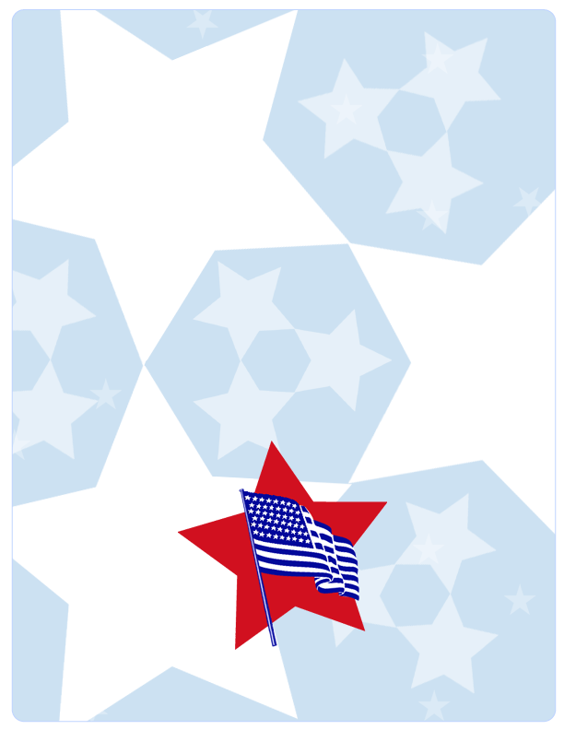Activities include tasting, smelling, and feeling the different ingredients as we make quesadillas, cookies, bread, Ice-cream and a cake!

**Week 7**

**July 14-18: Multicultural Art**

Activities include making cool multicultural creations as they learn about the world around them.

**Week 8**

**July 21-25: Summer Science**

Activities include experiments with colors, water, air, ice and much much more!

**Week 9**

**July 28- August 1: Recycled Art**

Activities include transforming items from home into beautiful art; the children will be amazed at the transformation from trash to treasure!

**Week 10**

**August 4-8: Summer Olympics**

Activities include egg toss, bag race, lime and spoon race, tug of war!

**Week 11**

**August 11-15: Under the Big Top**

Activities include clown costumes, face painting, cotton candy, snow cone and circus theme art projects!

**Please contact the school for more information:**

**4380 MacArthur Blvd NW, 2nd Floor**

**202-338-1557**